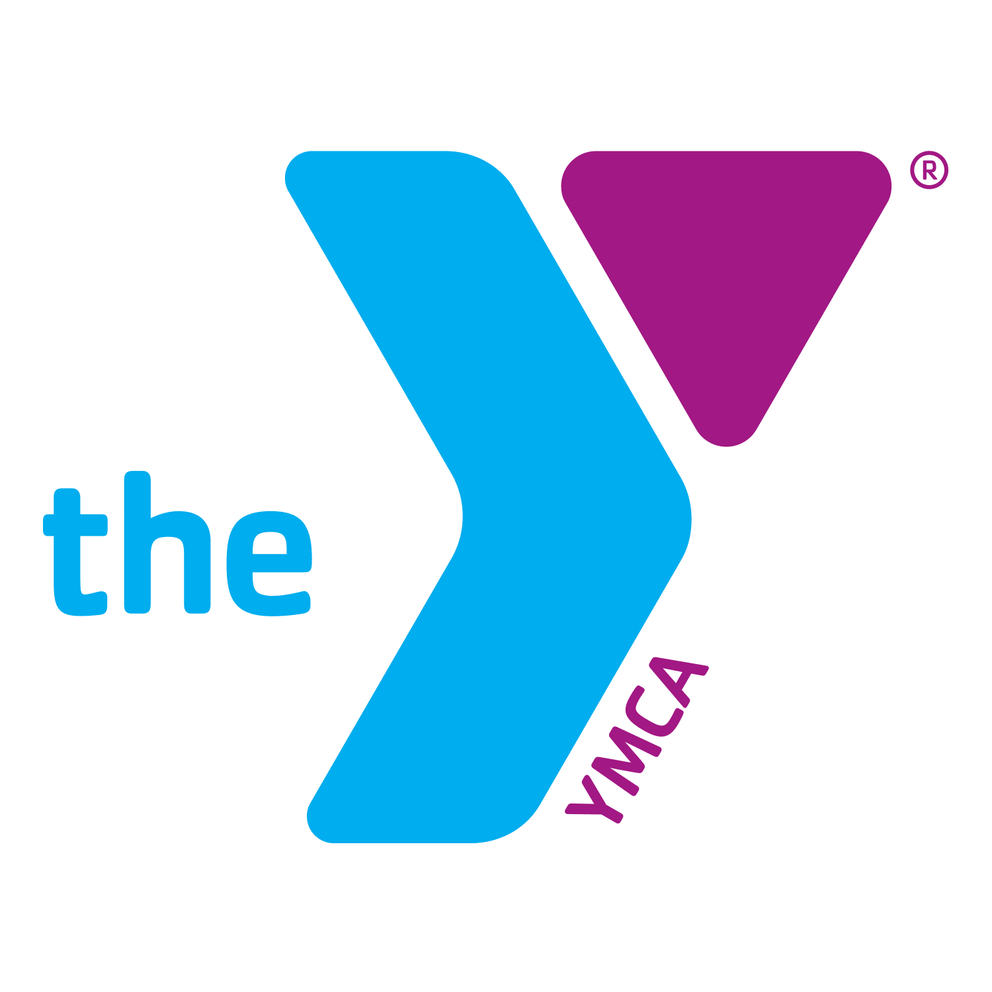
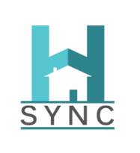
H-SYNC Navigator Court Referral Form – YMCA of Greater Seattle
Navigator Contact: Sheala Anderson | shealaanderson@seattleymca.org
Instructions: Fill out the below referral sheet for each youth and email document to: shealaanderson@seattleymca.org
Name of Youth | Youth Contact Info (phone #, email, Facebook, address) – separate with commas | Preferred Contact Method | Youth Date of Birth | ROI on File
Click or tap here to enter text. | Click or tap here to enter text. | Click or tap here to enter text. | Click or tap here to enter text. | Click or tap here to enter text.
Name of Guardian | Guardian Contact Info (phone #, e-mail, Facebook, address) - separate with commas | Preferred Contact Method | JUV# | Name/Contact of Referral Source
Click or tap here to enter text. | Click or tap here to enter text. | Click or tap here to enter text. | Click or tap here to enter text. | Click or tap here to enter text.
Reason for Referral - Check all that apply as reported by youth or discovered during interviews/interactions:
☐ Youth is being referred due to PACT flag.
☐ Youth is being restricted from home by a guardian (kicked out).
☐ Conflict, violence, and or abuse between two or more people living in the home (may or may not involve criminal charges).
☐ Youth or siblings are living with friends/relatives who are not guardians (couch surfing).
☐ Youth or family is unhoused (on the streets, in a car, in a shelter, etc…).
☐ Family is at risk of eviction.
☐ Youth is releasing from detention and caregivers unable/unwilling to pick up.
☐ Youth has a history of running away.
☐ Other: Click or tap here to enter text.
Referrer’s Comments
Click or tap here to enter text.

